TRANSPORT
Travel by road: leave M6 J36 - A590, follow the signs for Barrow. Then A595 signs for Workington and Askam. In Askam cross the level crossing into Duddon Rd to the venue 100yds on right.
Travel by rail: Askam railway station
(Cumbria coast rail line)
Note: no trains on a Sunday on this line
Alternatively: train to Barrow-in-Furness and alight at Ulverston/Dalton or Barrow.
For those without car transport who are arriving by train or staying in Ulverston/Barrow – let the organisers know and they will arrange transport to/from Askam.

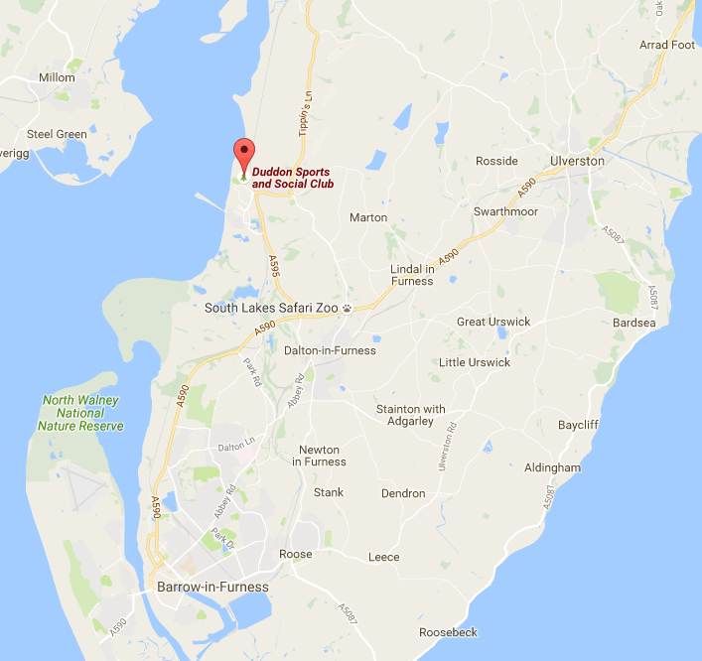

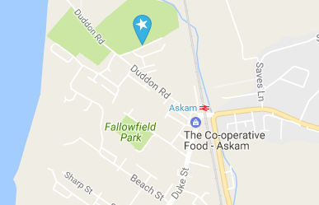

Refreshments
Food and drink available throughout the Championships
at the Duddon Sports & Social Club

Accommodation

Ulverston
The Stan Laurel Pub
`The Home of Ulverston Chess` Tel: 01229 582814
The King`s Head Pub Tel: 01229 343137 or 07584894 27
Lonsdale House Hotel Tel: 01229 588278
The Farmer`s Arms Tel: 01229 584469

Barrow
Travelodge Tel: 0871 9846281
Premier Inn Tel: 0871 5279430
Lisdoone Hotel: Tel: 01229 827312
Fairway Hotel Tel: 01229 461200

Dalton
Number 19 Guesthouse Tel: 07885 265237



Presents
The Cumbria Individual Open
Chess Championships

24th, 25th & 26th March 2017

The Duddon Sports & Social Club,
James St, Askam-in-Furness,
Cumbria, LA16 7AH
Tel no: 01229 464576

ECF GRAND PRIX EVENT

A 5 Round Swiss Event
2 Sections
Major & Minor

Prize Fund around £500

ENTRY FORM

Send to: Peter Hanks
The Welcome, Quay St. Ulverston,
Cumbria, LA12 9AT

Tel: 07833934031/01229480584
email: hanksy1@btinternet.com

Section_____________________ Entry Fee_________________
(The Organisers reserve the right to move a player into a different section)

Round Bye Required (if applicable) _______________

ECF Grade__________________ DOB_____________________

ECF Grading No__________________

ECF Member Type: Bronze/Silver/Gold/Platinum (delete as required)

ECF Membership No__________________________________

Name_____________________________________________________

Address___________________________________________________

_________________________________Postcode_________________

Telephone No____________ email address ____________________

Club______________________________________________________

Donation to Congress Expenses________________________________

Enclosed Cheque/Postal Order
(Payable to ‘Cumbria Chess’) £…………………………………………..

TOURNAMENT SECTIONS

MAJOR Open to all players

Best Cumbria player: Higgins Castle

MINOR Restricted to players graded under 130

Best Cumbria player: Keswick Knight
Best U100 Cumbria player: Bob Greenhalgh Trophy
Entry Fee £25
Silver/Gold ECF Members Entry fee minus £7
Bronze ECF Members Entry fee (this will upgrade you to Silver)
Non-ECF Members Entry fee (fee includes ‘pay-to-play’)

Prizes: Major 1st Prize: £175, 2nd Prize £75
Minor 1st Prize: £150, 2nd Prize £50

Grading prizes in each section - dependent on the level of entries

Entries By: 22nd March 2017
Late Entries: At the discretion of the organisers and subject
to £1 surcharge

TIMETABLE Opening Friday 18.50
Round 1 Friday 19.00-22.30
Round 2 Saturday 10.00-13.30
Round 3 Saturday 14.30-18.00
Round 4 Sunday 10.00-13.30
Round 5 Sunday 14.30-18.00

Rate of Play: All moves in 1 hour 45 miniutes each (no fast finish)
Byes: Players may take two ½ point byes and in any round
Re-pairing: Players will be defaulted/re-paired after 30 minutes

Congress Conditions
All prizes subject to number of entries.
All decisions of the organisers pertaining to the congress shall be final.

